

C346 MOBILE APP DEVELOPMENT
CA2 MOBILE APP DOCUMENT

ECOCOMMUTE

Members & Student ID:
Irfan bin Imran (24048581), Randy Ng Kuang Peng (24047653)
Team Number: 6
Date: 31/01/2026

Overview
EcoCommute is a React Native app that helps users log their daily commutes and check live public transport information. The commute logs are stored through our backend web service, so users can retrieve the same history after closing the app.
Transport utility screens (Bus Routes, Next Bus, Train Alerts) are included to reduce the “unknowns” that make public transport feel inconvenient.

Main Features

User Account Management
- Register a new account and sign in with email + password.
- Edit profile fields (name, username, phone).
- Upload/update avatar (profile picture).
- Log out to clear the saved session on the device.

[Screenshot: Login screen]
[Screenshot: Register screen]
[Screenshot: Profile screen (logged-in)]

Commute Recording
Users can record a commute trip with details such as:
- From label and To label (searchable via location autocomplete).
- Mode (Walk / Cycle / Bus / MRT / Car / Mixed).
- Start time, end time, duration (minutes), distance (km).
- Optional purpose and notes.

From the app, users can also:
- Add a new commute.
- Edit an existing commute.
- Delete a commute entry.
- Attach a photo to a commute (optional).
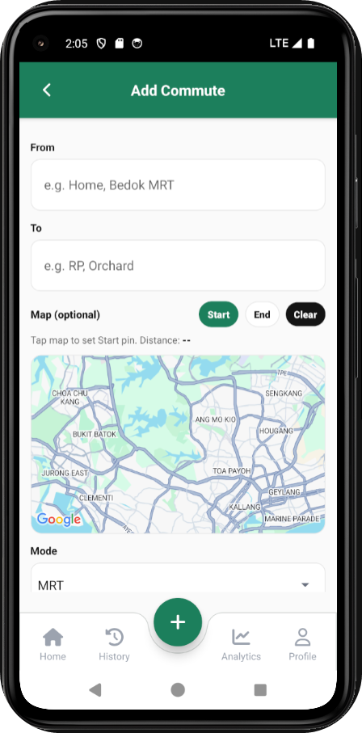
[Screenshot: Add commute screen]
[Screenshot: Edit commute screen]

Commute History
The History screen lists all stored commutes in descending order (latest first). To help users find older trips quickly, the list supports filtering and search.
- Filter by mode.
- Filter by month and year.
- Search across route labels, purpose, and notes.

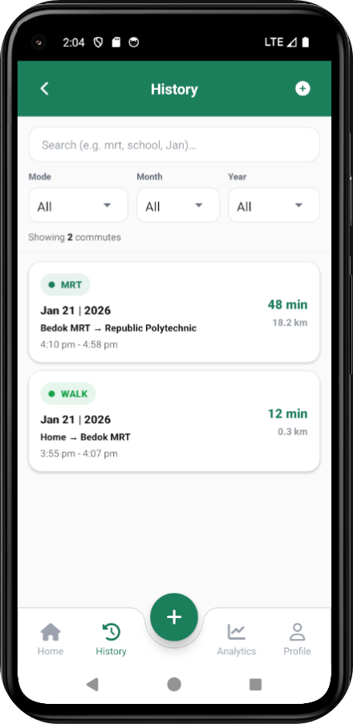
[Screenshot: History screen (default)]

[Screenshot: History filters and search in use]

Commute Details
Selecting an item from History opens a detail view with:
- Full route labels (From -> To).
- Timing (start/end), duration, and distance.
- Purpose and notes (if provided).
- Actions: Edit, Delete, and Image upload/view (if supported).
[Screenshot: Commute detail screen]

Home Dashboard
The Home screen gives a quick snapshot so users don’t need to dig through history just to see progress.
- Today’s trips and minutes.
- Weekly totals (trips, minutes, distance).
- Most-used mode this week.
- Three most recent commutes.
- Quick shortcuts to transport utilities.
The Home screen also includes an environment snapshot card (e.g., temperature/rainfall indicators) to help users anticipate conditions before travelling.

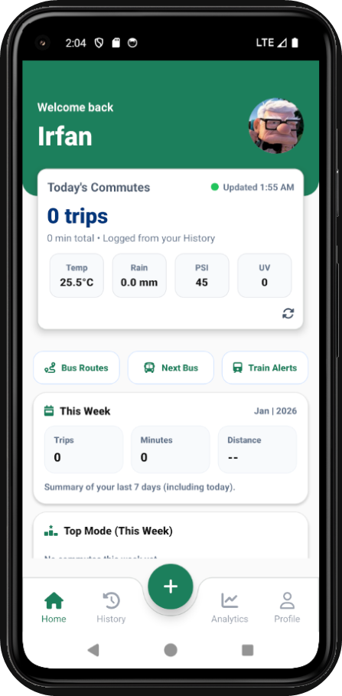
[Screenshot: Home screen dashboard (top)]

[Screenshot: Home screen dashboard (scroll view)]

Bus Route Search
Users can search a bus route by service number and direction (1 or 2). The screen displays:
- Stop sequence and (where available) stop names.
- Distance along the route.
- First/last bus times by day type (weekday, Saturday, Sunday/PH).
[Screenshot: Bus route search screen]
[Screenshot: Bus route results list]

Next Bus Timing
Users enter a bus stop code to view arrival information per service:
- Next / 2nd / 3rd bus timing.
- Estimated minutes (e.g., “Arr”, “5 min”).
- Load status tag (SEA/SDA/LSD) and wheelchair accessibility indicator (if present).
- Refresh button and pull-to-refresh; auto-refresh approximately every 20 seconds.
[Screenshot: Next bus screen (results loaded)]
[Screenshot: Next bus screen (refresh behaviour)]

Train Service Alerts
This screen displays train service advisories (when available), including:
- Overall status (Normal / Disrupted).
- Affected line and stations (if provided).
- Alternative travel arrangements (e.g., shuttle bus) when stated.
- Refresh button; auto-refresh approximately every 60 seconds.
[Screenshot: Train alerts screen (normal status)]
[Screenshot: Train alerts screen (disruption example)]

App Navigation
The app uses a bottom navigation bar for the main sections, plus stack navigation for detail screens (e.g., opening Commute Details from History).
Screen Name | Purpose
Home | Dashboard overview + quick actions
History | View all saved commutes + filter + search
CommuteDetail | View commute details + edit/delete
AddCommute | Add a new commute
EditCommute | Edit existing commute
BusRoutes | Search for bus route stops
NextBus | View next bus arrivals using stop code
TrainServiceAlert | View train disruptions and advisories
Login | User login
Register | Create new user account
Profile | View/edit user info + avatar + logout

App Usage Guide
- Sign in (or register a new account) from the Profile screen.
- Add a commute from the History screen (tap the add button), then save.
- Open any commute in History to view details. Use Edit or Delete as needed.
- Use Bus Routes / Next Bus / Train Alerts to check live public transport information.
- Log out from Profile to clear the saved session.
[Screenshot: Usage guide collage (key steps)]

Requirements
- Backend web service must be running for user and commute features.
- Android Emulator base URL uses http://10.0.2.2:3000 to reach the host machine.
- Uploaded images (avatars / commute images) are served from /uploads/<filename>.
[Screenshot: Example of .env / base URL configuration in the app (if applicable)]

